Please study GAMS and check the sample codes at

1. Transportation problem: <https://github.com/xzhou99/learning-transportation/tree/master/GAMS_code%20-space-time-network/0%20transportation>
2. Shortest path problem: <https://github.com/xzhou99/learning-transportation/tree/master/GAMS_code%20-space-time-network/1%20shortest_path>

and provide the GAMS codes and solution output for the following problems.

**1. Transportation problem:**

Cities 1 and 2 have 100K and 200K passengers per year, respectively. Airports 1 and 2 can accept a demand of 150K and 150K passengers per year, respectively. The city-to-airport driving times are listed at right.

Please formulate the linear programming problem and solve it using GAMS Solver.

Reading. [http://web.mit.edu/15.053/www/AMP-Chapter-08.pdf section 8.2](http://web.mit.edu/15.053/www/AMP-Chapter-08.pdf%20section%208.2)

Given:

$a(i)$: the demand of city $i$, $i∈\{1,2\}$

$b(j)$: the capacity of airport $j$, $j∈\{1,2\}$

$c\left(i,j\right)$: the driving time from city $i$ to airport $j$

To find:

$x(i,j)$: the passengers traveling from city $i$ to airport $j$

$z$: the total travel cost

Model:

$$\min{\sum_{i,j}{\{x(i,j)×c(i,j)\}}}$$

Subject to

$$\sum_{j}{x\left(i,j\right)=a\left(i\right), ∀i}$$

$$\sum_{i}{x\left(i,j\right)=b\left(j\right), ∀i}$$

$$x(i,j)≥0$$

Sample solutions from GAMS: $x\left(1,1\right)=100, x\left(2,1\right)=50, x\left(2,2\right)=150, and z=500$

1. **Shortest path problem**

(you can assume the link length as 1 as a default value and try different values as a sensitivity test)

Reading. [http://web.mit.edu/15.053/www/AMP-Chapter-08.pdf section 8.2](http://web.mit.edu/15.053/www/AMP-Chapter-08.pdf%20section%208.2)

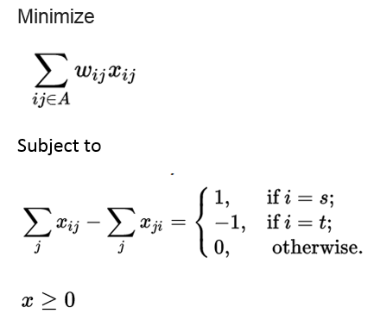 

**3. Dynamic system optimal problem (For Ph.D. students)**

Reference:

[Capacitated transit service network design with boundedly rational agents](javascript:void(0))

J Liu, X Zhou

Transportation Research Part B: Methodological 93, 225-250

Space-time network:

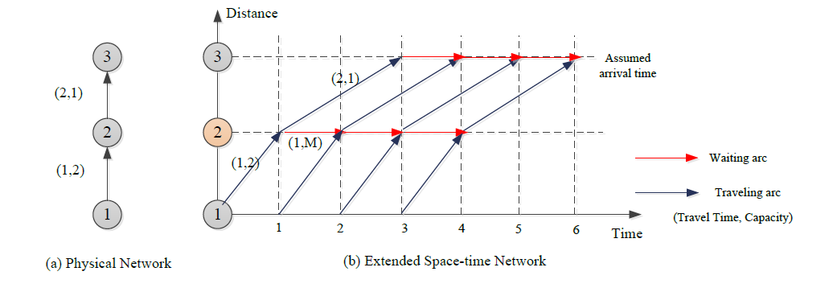

Agent-based model:

Minimize $Z=\sum_{f}{\sum_{(i,j,t,t')}{c_{i,j,t,t'}×x_{i,j,t,t'}^{f}}}$ (16)

Subject to

$\sum_{\left(i,j,t-t_{i,j},t\right)∈A}{x_{i,j,t-t_{i,j},t}^{f}}-\sum_{\left(j,k,t,t+t_{j,k}\right)∈A}{x_{j,k,t,t+s_{j,k}}^{f}}=\left\{\begin{matrix}-1 & ∀f∈F, j=O\left(f\right) and t=DT(f) \\ 1 & ∀f∈F,j=D\left(f\right) and t=T \\ 0 & otherwise\end{matrix}\right.$

$\sum_{f∈F}{x_{i,j,t,t+t_{i,j}}^{f}}≤{Cap}_{i,j}, ∀(i,j,t,t+t_{i,j})∈A,t=1,2,…,T$ (18)

$x_{i,j,t,t'}^{f}=\{0,1\}$

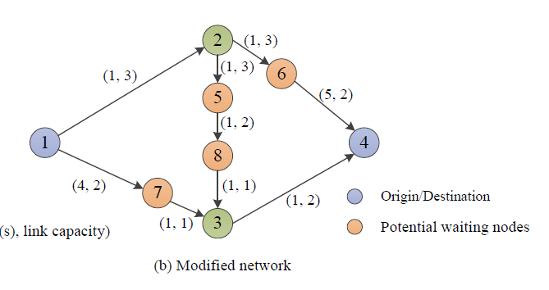 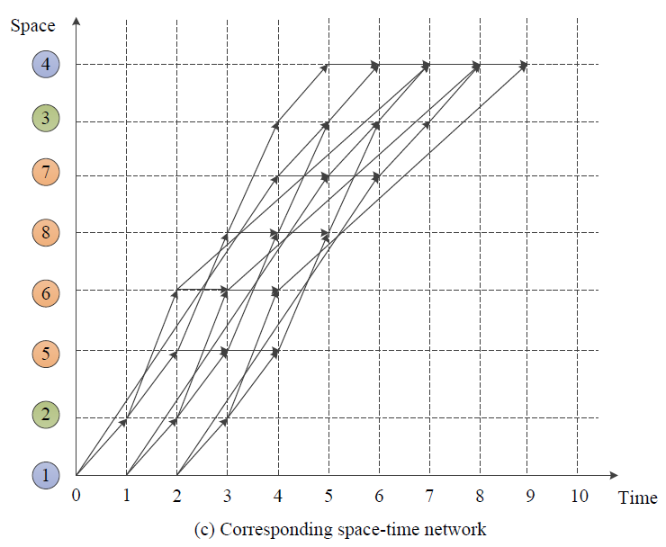

Reference: <https://github.com/xzhou99/learning-transportation/blob/master/GAMS_code%20-space-time-network/4%20transit_network_design_and_branch_and_bound/Case_1_Transit_network_design_LR.gms>